Real Time IoT Based Pre & Post Machine Diagnosis & Fault Analysis

|  |  |  |
| --- | --- | --- |
| Anson Saju George  *Computer Science and Engineering Karunya Institute of Technology and Sciences,* Coimbatore, India [ansonsaju@karunya.edu.in](mailto:ansonsaju@karunya.edu.in)  Sweetlin Jeba S  *Computer Science and Engineering Karunya Institute of Technology and*  *Sciences,* Coimbatore, India  [sweetlinjeba@karunya.edu.in](mailto:sweetlinjeba@karunya.edu.in) | Ancy Jenifer. J  *Computer Science and Engineering Karunya Institute of Technology and Sciences,* Coimbatore, India [ancyjenifer@karunya.edu](mailto:ancyjenifer@karunya.edu)  V Sudharshan Reddy  *Computer Science and Engineering Karunya Institute of Technology and Sciences,* Coimbatore, India  [vsudharshan@karunya.edu.in](mailto:vsudharshan@karunya.edu.in) | Esther Alice Mathew  *Computer Science and Engineering Karunya Institute of Technology and*  *Sciences,* Coimbatore, India  [estheralice@karunya.edu.in](mailto:estheralice@karunya.edu.in) |

***Abstract*—Machines have become an integral part in every aspect of human life. Which entails perpetual perusal of the contraption. The last few years have shown a tremendous inflation in the domain of machine diagnostics, alternatively, fault diagnostics. Machine diagnosis has its significance in resolving the conditions of different machine parts for determining various mechanical failures. Machine health monitoring is critical in ensuring that machines operate at their optimum performance levels and minimizing downtime due to unexpected failures. The fault detection system of our device is designed based on the machine’s functional and physical properties. The machine health monitoring device can be spanned across a large range of industries, including manufacturing, mining, and energy. This paper proposes a comprehensive diagnostic tool that takes in vibrations, alignment, temperature, and other parameters from machines and provides accurate and timely diagnostics. By providing accurate and timely diagnostics, the device can help to minimize downtime and reduce maintenance costs**

***Keywords*—*Internet of things (IoT), Machine health monitoring, vibration analysis, thermal imaging, laser alignment, diagnostics*.**

1. Introduction

The machine diagnostics process is vital to ensure optimal performance and safety in any industrial setting. By regularly checking and calibrating machines, businesses can avoid costly downtime and accidents. The first step in machine diagnostics is to check the machine's sensors. These devices are responsible for monitoring various aspects of the machine, such as temperature, pressure, and vibration. If any of the sensors are not functioning properly, it can cause the machine to operate inefficiently or even dangerously.

Next, the machinery itself must be inspected for wear and tear. This can be done visually or with special instruments that measure things like thickness of metal parts or alignment of moving parts. If any problems are found, they must be fixed before the machine is used again. Finally, the operators of the machinery must be properly trained in its use and safety procedures. They should also be familiar with the diagnostic process so that they can spot potential problems early on. By following these simple steps, businesses can keep their machines running safely and efficiently for years to come.

Machines are critical components of many industries, and their performance directly affects the productivity and profitability of these industries. Unexpected machine failures can result in downtime, loss of revenue, and increased maintenance costs. Machine health monitoring is, therefore, critical in ensuring that machines operate at their optimum performance levels and minimizing downtime due to unexpected failures.

There are various approaches to machine health monitoring, including condition-based monitoring, predictive maintenance, and proactive maintenance. Condition-based monitoring involves collecting data on machine parameters such as vibrations, temperature, and alignment and using this data to diagnose any potential problems. Predictive maintenance uses machine learning algorithms to predict when maintenance is required based on data from the past. Proactive maintenance involves regularly inspecting and maintaining machines to prevent unexpected failures.

This paper proposes a comprehensive diagnostic tool that takes in vibrations, alignment, temperature, and other parameters from machines and provides accurate and timely diagnostics. The proposed machine health monitoring device comprises three main components: sensors, data acquisition system, and a diagnostic module. This paper consists of six parts. In part three, all the components that are used for the prototype are specified, along with their functionality. In part four , we explain the use of the devices and where this device has been used before is specified.

1. Related Works

There are other researchers that have pondered on this very topic. The applications that have been reported so far are:

1. is a paper written by Tran Van Tung and Bo-Suk Yang. In this paper they summarize and classify recent published techniques in diagnosis and prognosis of rotating machinery. Furthermore, it also discusses the opportunities as well as the challenges for conducting advance research in the field of machine prognosis.

Diagnosis and Prognosis are two of the most important parts in a CBM system. Diagnosis is the ability to spot a defect, isolate and identify which component failed and then deciding the impact the failed component could have on the overall health of the system. Prognosis on the other hand, is the capability to use available observations to predict the upcoming states of the machine, that is, to expect the error that is bound to come based on the data collected.

They then go on to tell the different approaches of machine fault diagnosis, which include model-based approach, knowledge-based approach and pattern recognition -based approach. The machine fault prognosis approaches include statistical approaches, model-bases approaches, data-driven based approaches and challenges and opportunities of machine prognosis.

1. This paper focused more on generalization of fault diagnosis. They address the challenges by presenting an effective transfer learning (TL) - based strategy for domain generalization and damage classification at the edge level.
2. This paper analyzed the evolution and application of multi-source sensing data fusion models and innovation in mechanical equipment fault diagnosis and prediction. [4] Focuses on the online monitoring and fault diagnosis through data collection and convergence and stress wave technology, this technology is efficient in monitoring the working of the machine and deducting the expected fault and the machine’s life cycle.

[10] The monitoring of home appliances and control them through a controller makes the user to maintain various devices at the same time. This paper explains about the Fault Prediction system which is detecting the faults in appliances without human intervention. This system is integrated with the support of cloud computing, Internet of Things and mobile application. [5] This article focuses on the machine diagnostics with the help of Artificial Intelligence in the diagnosis of complex systems. [9] From this paper we can understand the idea of early fault diagnosis in machinery. The system extracts multi-dimension features from the identified signal to supervise the various features of the signals. A normal feature space is initiated and therefore any abnormal signal can be detected and thus the faults in the complex system is detected efficiently.

1. Vibration Analysis, axial flux measurements to diagnose fault in electrical machines have been discussed in this paper. And it also explains about the stator, rotor and eccentricity-based faults.
2. Components Used

The machine health monitoring device comprises three main components: sensors, data acquisition system, and a diagnostic module. The sensors are installed on the machine to collect data on various parameters such as vibrations, temperature, and alignment. The data acquisition system acquires the data from the sensors and stores it in a database for analysis. The diagnostic module

analyses the data and provides accurate and timely diagnostics on the health of the machine.

* 1. **LM35:** A typical temperature sensor. It has an analog output voltage that is proportional to the temperature, the output is in Centigrade (Celsius). It uses the basic principle of a diode to compute the temperature.

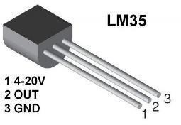

Fig.1. LM35 sensor

* 1. **ESP32:** It is a Wi-Fi and Bluetooth MCU. It includes processors, memory, wireless connectivity and other peripherals.

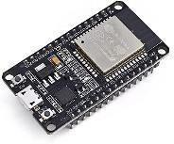

Fig. 2. ESP32

* 1. **MPU-6050:** It is a composition of a 3- axis gyroscope and a 3-axis accelerometer ([8] also uses a tri-axial accelerometer) and a DMP- digital motion processor integrated on a single chip.

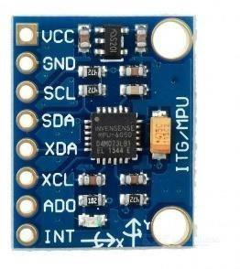

Fig.3. MPU-6050

* 1. **SW-420:** It is a vibration sensor. Its sensitivity can be controlled using a potentiometer and an IC. When there is an absence of vibrations or low vibration, the logic provided by the sensor is low. And when there are vibrations detected, the logic provided by the sensor is high.

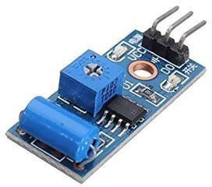

Fig.4. SW-420

1. Methodology
2. Sensors:

The sensors are installed on the machine to collect data on various parameters such as vibrations, temperature, and alignment. The sensors used in the proposed device include accelerometers, temperature sensors, and laser alignment sensors. The accelerometers measure the vibrations of the machine, while the temperature sensors measure the temperature of the machine components. The laser alignment sensors are used to ensure that the machine components are correctly aligned.

1. Data Acquisition System:

The data acquisition system acquires the data from the sensors and stores it in a database for analysis. The data acquisition system used in the proposed device comprises a microcontroller and a data logger. The microcontroller interfaces with the sensors to acquire data, while the data logger stores the data in a database.

1. Diagnostic Module:

The diagnostic module analyses the data acquired by the data acquisition system and provides accurate and timely diagnostics on the health of the machine. The diagnostic module uses a combination of vibration analysis, thermal imaging, and laser alignment techniques to diagnose machine problems.

1. Vibration Analysis:

Vibration analysis is used to detect any anomalies in the machine's vibration patterns. [6] The vibration data acquired by the sensors is analyzed using Fourier analysis to obtain the frequency spectrum. The frequency spectrum is then used to identify any anomalies in the machine's vibration patterns, which may indicate potential problems such as misalignment, bearing wear, or gear damage.

1. Thermal Analysis

Thermography is an approach used to detect temperature inaptness in machines. It includes measuring the temperature of the surface of a machine, then inspect them to point out any hot spots or cold spots. This method can help identify problems like electrical faults, insulation defects and bearing defects. It is a noninvasive technique that requires specific environmental conditions and can be used remotely. However, it may not be apt for all types of machines.

1. Ease Of Use
2. *Machine diagnosis*

To understand the project in the way it is intended to, we must first understand what machine fault diagnosis is. Machine diagnosis is the monitoring of a machine’s or a device’s health to pick up on the faults and shortcomings of the device. It is an important part that later contributes to maintenance. When a fault is detected in the working of a machine, it is given for

rectification, i.e., the problem or the fault that surfaced will be dealt with, such that the problem never arises again.

Machine diagnosis is also used in the medical industry to detect and diagnose medical conditions or diseases. In this process, the machine uses the machine learning algorithm [9]. It involves training algorithms to recognize patterns and classify data bases on specific parameters. It can be used in numerous medical fields including radiology, pathology and dermatology. Fault diagnosis is the process of tracing a fault occurred by means of its symptoms, analyzing test results and by applying knowledge. It plays an important part in the smooth functioning of any device for a prolonged period of time. Another key aspect of machine fault diagnosis is the use of algorithms of machine learning to automatically classify and diagnose faults based on historical data or expert knowledge. [8]

1. *Our idea*

The proposed system is an IoT- based solution to monitor the conditions of an industrial device. Our goal is to implement a device that is used at the manufacturing stage of the product, not only then but also when the device is in the hands of the customer. Our device will help monitor the condition and health of the product while manufacturing. It will ensure that the product works in the way the manufacturer intended it to It also, in turn, guarantees a smooth user experience.

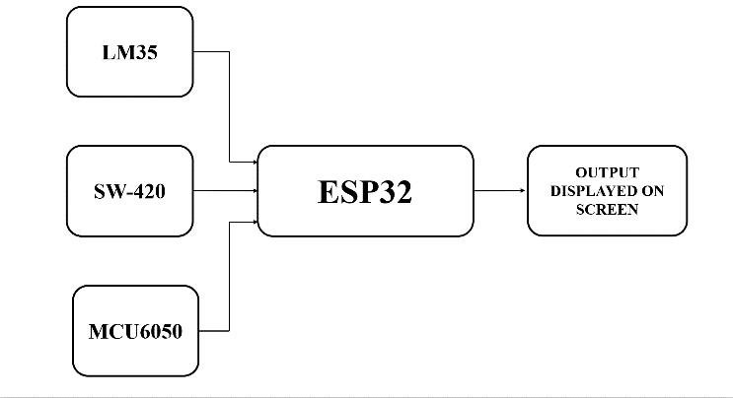

* + Fig.5. Block Diagram of the Device

It takes real- time inputs from the machine continuously. The machine diagnosis will also be done at the hand-held stage, that is, when the customer has purchased the project and uses it.

This, again reduces the impact it would have on the user experience if this step was avoided. When there is an active device that monitors the health of the product and establishes the standard that the product has to reach, it reduces the burden on then user.

The proposed machine health monitoring device uses a combination of vibration analysis, thermal imaging, and laser alignment techniques to diagnose the machine problems. Vibration analysis is used to detect any anomalies in the machine’s vibration patterns.

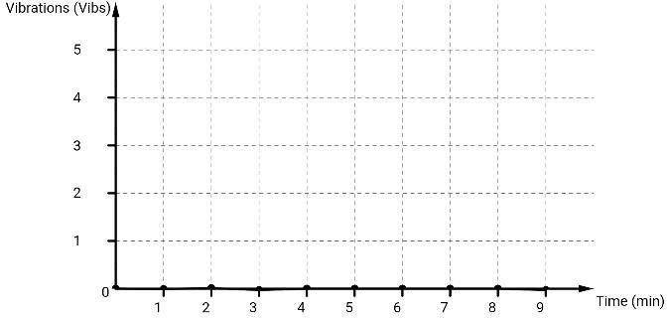will be generated and how smoothly the machine goes about the set process.

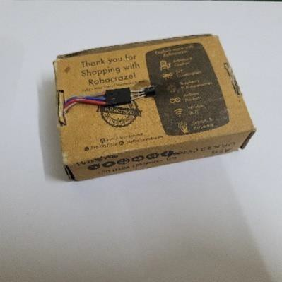

LM35 sensor

*:*

Fig.6. LM35 sensor

The thermal imaging is utilized to detect any hotspots that may indicate malfunctioning components or wear and tear in the device. Most devices tend to heat up when there is a

defect, which makes thermal sensing an appropriate way of detecting faults. Laser alignment is used to ensure that the machine components are correctly aligned, which in turn reduces any risk of failure.

Gyroscopes and accelerometers are kept in place to measure any changes or inconsistency in the movement or position of the machine that is being diagnosed.

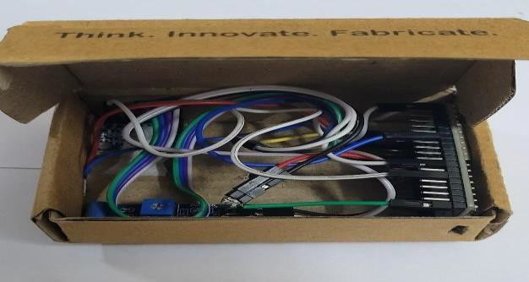

Fig.7. Prototype

This device will be attached to the machine that needs to be analyzed. A standard of how the machine is supposed to work, or the ideal behavior is fed to the device. Now, after the machine starts working, it will be constantly monitored for any deviations from the expected behavior. When the ideal behavior is stored to the device, it will take constant inputs from the machine that is working. One thing to keep in mind while creating the baseline that the machine needs to follow Is that the machine can be allowed a certain amount of wear and tear, it is inevitable. But we must determine how much deviation from the expected behavior is acceptable, so that it doesn’t affect the health of the machine in the long run. One of the main issues is the setting of the threshold.

Setting a low threshold can lead to many false alarms [5]. On the other hand, setting a very high threshold can lead to not detecting any error at all in serious situations. This is not suitable due to obvious security reasons. In the grand scheme of things, when a device brings too much harm to the system, damage control must be done and the error, or defect, is to be dealt with. One way to visualize the whole process is by using graphs. We plot a graph recording the standard way that a machine should function, the ideal behavior of a machine and the way they react to the commands given. The expectation of how the result

Fig.8. Graph of machine without defect

This data that is being stored is used as the reference to measure the health and the apt functioning of the machine. This being set as the reference line will give an accurate report on how far the machine is from the ideal health. It has potential to show which particular component is defective and how much of a defect is observed. Now given in *figure 9* of a machine that has a defect, which in turn effects the overall health of the machine.

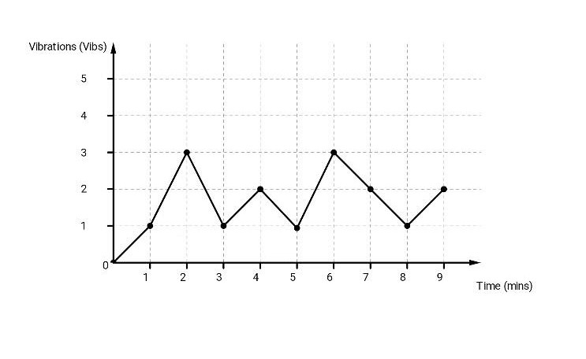

Fig.9. Graph of machine with defect

The graph that goes away from the standard line depicts how much of a fault is there in the machine, which, when observed, can be dealt with accordingly.

The ore that the line deviates from the ideal graph implies how much a machine deviates from ideal behavior.

This fault diagnosing system is also portable, which means that the device can be implemented theoretically anywhere. It also gives the device far more authenticity and accessibility when compared to other such devices.

The portability makes it accessible, easily usable and more convenient, which will, predictably make it more acceptable to a larger crowd.

Fig.10 is the prototype, a primary version of the device.

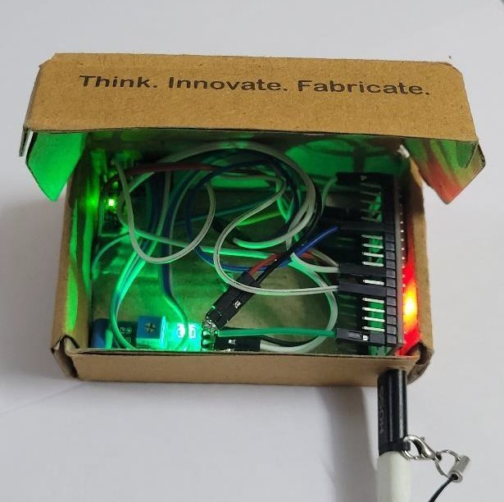

Fig.10. Prototype, primary version

1. RESULT

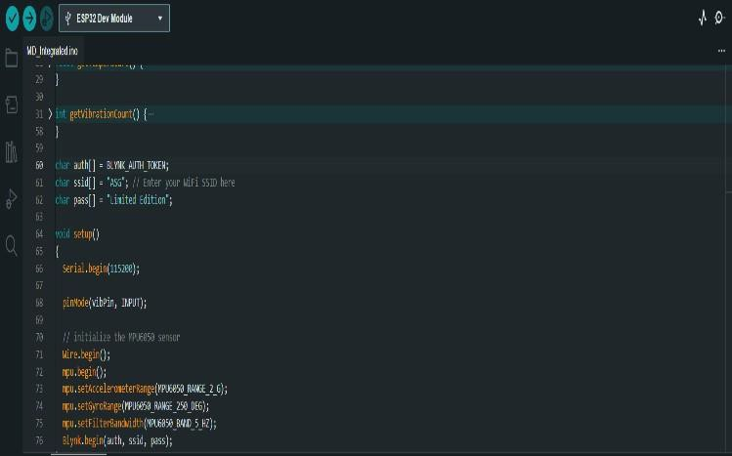

Fig.11. Program

Fig.12 is an image of the program being dumped in the software Arduino IDE to integrate it with the ESP32 development board. The output of the mentioned program, that integrates the temperature sensor LM35, the accelerometer and gyroscope and the vibration sensor is Fig.13

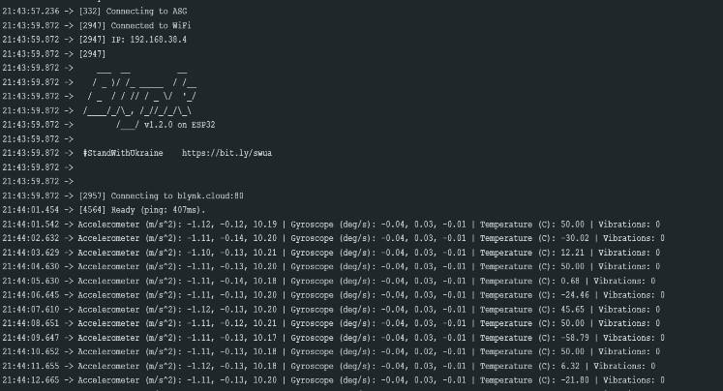

Fig.12. program being dumped into Arduino

The user interface, i.e., where the machine can interact with the user and keep the user updated on the status of the machine is done using ‘The Blynk’ application. Here the user can keep track of the faults in the machine and estimate how it is going to affect the health of the said machine overall. The UI has been simplified, making it easier to for a diverse crowd by making it easier to

comprehend. The dashboard displays the data from the previous week, the last day, the past six hours, the hour that just passed and the latest update from when it was last checked, simultaneously. Data from earlier than that is stored securely and can be accessed only with authentication. Vibrations from all the three axes – X, Y and Z – are also displayed on the dashboard, making it easier for the user to access.

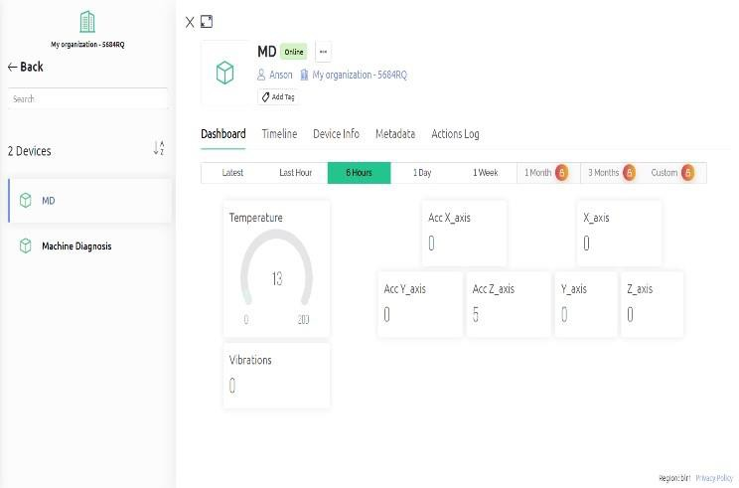

Fig.13. Output - Dashboard

This machine diagnosis prototype incorporates an accelerometer, gyroscope, vibration sensor, and temperature sensor have various potential applications in different domains. One of the primary advantages of the device is its portability, making it easy to carry and use in various settings.

One potential application of this device is in industrial machines, especially rotary machines, where it can monitor the machine for any errors in areas where it is more prone to defect. The accelerometer and gyroscope can detect any changes in the machine's movement, and the temperature sensor can detect any overheating issues that could potentially cause damage.

Another application of this device is in robotics. By attaching the device to robotic arms or legs, it can trace any malfunction in their movements, allowing for prompt diagnosis and repair. This can help prevent potential accidents and malfunctions, increasing the safety and efficiency of the robotic system.

The device's ability to customize its diagnosis based on the machine's threshold is another added advantage. Each machine has different thresholds, and the diagnosis can be tailored accordingly, ensuring that the device is accurate and effective in its diagnosis.

The ESP32 microcontroller used in the prototype of this device is a powerful and versatile microcontroller, capable of performing complex calculations and processing data from multiple sensors simultaneously. This makes it an ideal choice for developing a portable machine diagnosis device. The ESP32 microcontroller has vast potential applications in various domains. Its portability, customizable diagnosis, and ability to detect malfunctions in real-time make it a valuable tool in increasing the efficiency and safety of different systems. Apart from the

industrial and robotic applications, the machine diagnosis device can also be used in the automotive industry, where it can monitor different parts of a vehicle for any potential issues. For instance, it can monitor the vibration levels of the engine and other components, detect any changes in the temperature, and analyze the vehicle's movements using the accelerometer and gyroscope sensors.

The device can also be used in the healthcare industry to monitor patients' movements and detect any abnormalities. For example, it can be attached to a patient's leg to detect any changes in their gait, which could be an indication of an underlying medical condition.

Another advantage of the machine diagnosis device is its real-time monitoring capabilities. By analyzing the data from the different sensors in real-time, it can provide instant feedback on any potential issues, allowing for prompt diagnosis and repair.

The device's portability also makes it ideal for remote monitoring. It can be used to monitor equipment in remote locations, such as oil rigs or mines, without the need for physical presence. This can help reduce downtime and increase the efficiency of operations.

Additionally, the device's ability to store and analyze large amounts of data over time makes it a valuable tool for predictive maintenance. By analyzing historical data, it can predict when a machine or system is likely to malfunction, allowing for preventative measures to be taken before a breakdown occurs.

In conclusion, the machine diagnosis device has numerous potential applications in different industries, thanks to its portability, real-time monitoring, and predictive maintenance capabilities. Its ability to detect malfunctions in real-time, customizable diagnosis, and versatility make it a valuable tool for increasing efficiency and reducing downtime in different systems.

1. Conclusion

Machine diagnostics is a crucial procedure for locating problems, issues, and flaws in equipment. To guarantee that the machinery runs effectively and dependably, experts can utilize this method to recognize and isolate issues, ascertain their origins, and put the necessary remedial measures in place. The capability of machine diagnostics to anticipate and stop equipment breakdowns before they happen is one of their key advantages. Technicians can spot anomalies and spot possible faults before they cause breakdowns and downtime by continuously monitoring the functioning of the machines and analyzing data. By doing this, you may raise production, reduce repair costs, and guarantee worker safety. The capacity to enhance machine performance is a crucial component of machine diagnostics. Technicians can increase production quality, lower energy usage, and extend the life of the machinery by spotting and fixing operational inefficiencies. Businesses may benefit from large cost reductions and an improvement in profitability as a result.

Overall, the successful and efficient operation of industrial equipment depends on the machine diagnostics procedure. Businesses may ensure that their equipment runs dependably and efficiently, reduce downtime and repair costs, and boost productivity and profitability by employing a proactive diagnostic approach.

REFERENCE

1. Tung, T. V., & Yang, B. S. (2009, March 1). Machine Fault Diagnosis and Prognosis: The State of The Art. International Journal of Fluid Machinery and Systems, 2(1), 61–71. <https://doi.org/10.5293/ijfms.2009.2.1.061>
2. Asutkar, S., Chalke, C., Shivgan, K., & Tallur, S. (2023, March). TinyML-enabled edge implementation of transfer learning framework for domain generalization in machine fault diagnosis. Expert Systems With Applications, 213, 119016[.](https://doi.org/10.1016/j.eswa.2022.119016) <https://doi.org/10.1016/j.eswa.2022.119016>
3. Zhang, Xiaoran, Rane, Kantilal Pitambar, Kakaravada, Ismail and Shabaz, Mohammad. "Research on vibration monitoring and fault diagnosis of rotating machinery based on internet of things technology" Nonlinear Engineering, vol. 10, no. 1, 2021, pp. 245-254. <https://doi.org/10.1515/nleng-2021-0019>
4. Luxia Yang et al 2020 J. Phys.: Conf. Ser. 1575 012221
5. Ndeye Gueye Lo, Jean-Marie Flaus, Olivier Adrot. Review of Machine Learning Approaches In Fault Diagnosis applied to IoT System. ICCAD 2019 - 3rd International Conference on Control, Automation and Diagnosis, Jul 2019, Grenoble, France. ff10.1109/ICCAD46983.2019.9037949ff. ffhal02344344f
6. S. Nandi and H. A. Toliyat, "Fault diagnosis of electrical machines-a review," IEEE International Electric Machines and Drives Conference. IEMDC'99. Proceedings (Cat. No.99EX272), Seattle, WA, USA, 1999, pp. 219-221, doi: 10.1109/IEMDC.1999.769076.
7. T. Mian, A. Choudhary and S. Fatima, "Multi-Sensor Fault Diagnosis for Misalignment and Unbalance Detection Using Machine Learning," 2022 IEEE International Conference on Power Electronics, Smart Grid, and Renewable Energy (PESGRE), Trivandrum, India, 2022,

pp. 1-6, doi: 10.1109/PESGRE52268.2022.9715938.

1. S. Aziz, M. Ahmed, S. Z. H. Naqvi, M. U. Khan, A. Imtiaz and

A. Waseem, "Machine Bearing Fault Diagnosis System using Tri-Axial Accelerometer," 2020 International Conference on Electrical, Communication, and Computer Engineering (ICECCE), Istanbul, Turkey, 2020, pp. 1-6, doi: 10.1109/ICECCE49384.2020.9179326.

1. Wen-Wu Shi, Hong-Sen Yan and Kai-Ping Ma, "A new method of early fault diagnosis based on machine learning," 2005 International Conference on Machine Learning and Cybernetics, Guangzhou, China, 2005, pp. 32713276 Vol. 6, doi: 10.1109/ICMLC.2005.1527507.
2. Bhavana, Kotte, et al. “Internet of Things Enabled Device Fault Prediction System Using Machine Learning.” Inventive Computation Technologies, Springer International Publishing, Nov. 2019, pp. 920– 27.

Crossre[f,](https://doi.org/10.1007/978-3-030-33846-6_101) [https://doi.org/10.1007/978-3-030-33846-6_101.](https://doi.org/10.1007/978-3-030-33846-6_101)

1. Z. Xiao, Z. Cheng and Y. Li, "A Review of Fault Diagnosis Methods Based on Machine Learning Patterns," 2021 Global Reliability and Prognostics and Health Management (PHM-Nanjing), Nanjing, China, 2021, pp. 1-4, doi: 10.1109/PHM-Nanjing52125.2021.9612779